**R Code for Examples in the book**

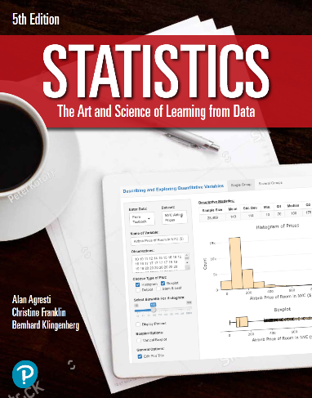

***“Statistics: The Art and Science of Learning from Data”***

**by Agresti, Franklin and Klingenberg, 5th edition**

**Chapter 12**

**Example 14: Variability of Athletes’ Strengths – Residual Standard Deviation**

## Reading in data

athletes <- read.csv(file='https://raw.githubusercontent.com/artofstat/data/master/Chapter12/highschool_female_athletes.csv')  
colnames(athletes) #check column names

## [1] "Athlete" "BP60" "maxBP..lbs."   
## [4] "LP200" "maxLP..lbs." "Situps..per.minute."  
## [7] "X40YD..sec." "VerticalJump..in." "SitReach..in."   
## [10] "MB..in." "SR..sec." "Age"   
## [13] "Height..in." "Weight..lbs." "Bodyfat...."   
## [16] "BMI" "Sport"

## Fitting regression model

linReg <- lm(maxBP..lbs. ~ BP60, data = athletes)  
linReg

##   
## Call:  
## lm(formula = maxBP..lbs. ~ BP60, data = athletes)  
##   
## Coefficients:  
## (Intercept) BP60   
## 63.537 1.491

## To obtain residual sum of squares

rss <- sum(linReg$residuals ** 2)  
rss

## [1] 3522.806

## To find total number of observations in the dataset

n <- length(linReg$residuals)  
n

## [1] 57

## To compute residual standard deviation

sqrt(rss / (n - 2))

## [1] 8.003188